The Certainty About an Uncertain Recovery

Austin Caudill

<https://www.thepetroguy.com>

7/1/2020

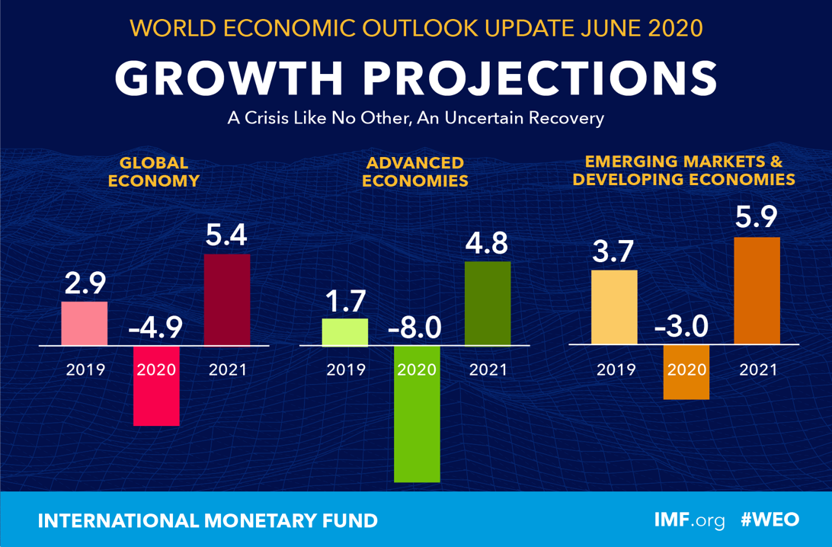

Newspapers, prime-time network newscasts, internet articles, and even random online conspiracists have all been making predictions since this pandemic first began: Would we enter a recession or depression, experience a "V-shaped" recovery, or would life ever return to "normal" at all? Those are the questions we have all been faced with over the past few months.

If there is one source that may have a little bit more of an informed opinion on the matter, it’s the International Monetary Fund (IMF,) a global organization with the primary purpose of ensuring the stability of the international monetary system. The key thing to point out here is that they are a non-partisan source of reliable information and data. In other words, their economic outlook isn't intended to sway American voters come election time (and that’s important.) Here is what they had to say in their June 2020 World Economic Outlook Update (aka WEO Report). This report is usually published quarterly by the IMF economists, although this particular iteration came one month early.

*"Global growth is projected at –4.9 percent in 2020, 1.9 percentage points below the April 2020 World Economic Outlook (WEO) forecast. The COVID-19 pandemic has had a more negative impact on activity in the first half of 2020 than anticipated, and the recovery is projected to be more gradual than previously forecast. In 2021 global growth is projected at 5.4 percent."*

Bleak assessment? Yes, absolutely for the near-term. But the silver lining here is there is a projected turnaround, albeit maybe not the "V-Shaped recovery" we were all hoping for. Although the IMF very explicitly states that these forecasts come with a higher degree of uncertainty than normal due to COVID-19, I choose to be the optimist in this situation. Positive GDP (Growth Domestic Product) growth necessitates increased hydrocarbon consumption. There are a variety of activities that increase GDP, and nearly all of them need hydrocarbons to make that happen. For example, consumer spending picks up leading to an increase in the manufacturing and transportation of goods. Anyone can see here that at a bare minimum additional fuel will be needed just to move said goods from one location to another, let alone the hydrocarbons needed for the processes to produce these goods.

And speaking of GDP, take a look at the chart below courtesy of Investopedia and data from the Federal Reserve Bank of St. Louis. GDP in the United States has been increasing over the past 15 years, with the only exception being the 2008 financial crisis. That's a lot of momentum in our favor, and I refuse to believe one bad year of a pandemic and oil trade war will reverse this trend.

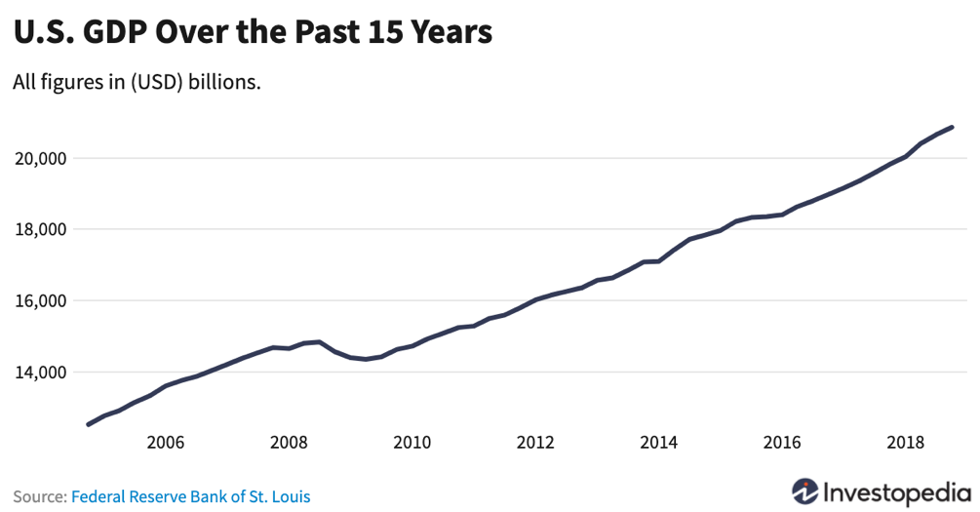

So, what's this "certainty about an uncertain recovery?"

While not much is known right now, one projection I'll make with absolute certainty is that the world will still need oil when this pandemic chapter finally closes. Then the question will again be whether OPEC+ can come together to favorably balance supply with demand. And that's a topic for another article.

<https://www.imf.org/en/Publications/WEO/Issues/2020/06/24/WEOUpdateJune2020>